Seoul Foreign School. Psychology.
IBDP: The Cognitive level of Analysis.
Name:

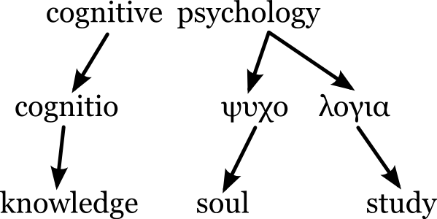

Command terms associated with assessment objective 1: Knowledge and comprehension.

Define | Give the precise meaning of a word, phrase concept or physical quality.
Describe | Give a detailed account
Outline | Give a brief account or summary
State | Give a specific name, value or other brief answer without explanation or calculation.

Command terms associated with assessment objective 2: Application and analysis.

Analysis | Break down in order to bring out the essential elements or structure.
Apply | Use an idea, equation, principle, theory or law in relation to a given problem or issue.
Distinguish | Make clear the differences between two or more concepts or items.
Explain | Give a detailed account including reasons or causes.

Command terms associated with assessment objective 3: Synthesis and evaluation.

Compare | Give an account of the similarities between two (or more) items or situations, referring to both (all) of them throughout
Compare and contrast | Give an account of the similarities between two (or more) items or situations, referring to both (all) of them throughout
Contrast | Give an account of the similarities between two (or more) items or situations, referring to both (all) of them throughout
Discuss | Offer a considered and balanced review that includes a range of arguments, factors or hypotheses. Opinions or conclusions should be presented clearly and supported by appropriate evidence.
Evaluate | Make an appraisal by weighing up the strength and limitations.
Examine | Consider an argument or concept in a way that uncovers the assumptions and interrelationships of the issue.
To what extent | Consider the merits or otherwise of an argument or concept. Opinions and conclusions should be presented clearly and supported with appropriate evidence and sound argument.

This work book as been completed to an excellent standard | 94 to 100% A- to A+
This workbook has been completed to a good standard | 85 to 93% B- to B+
This workbook has been completed to a satisfactory standard | 76 to 84% C- to C+
This workbook is generally of a poor standard | 70 to 75% D- to D+
The workbook has not been submitted or is of an unacceptable standard. | Below 70 Fail.
Final grade:

2. Cognitive level of analysis. General Learning outcomes

- Outline principles that define the Cognitive level of analysis

- Explain how principles that define the Cognitive level of analysis may be demonstrated in research through theories and/or studies

- Discuss how and why particular research methods are used at the Cognitive level of analysis.

- Discuss ethical considerations related to research at the Cognitive level of analysis.

Cognitive processes

5. Evaluate schema theory with reference to research studies.

6 Evaluate two models or theories of one cognitive process (for example, memory, perception, language, decision making) with reference to research studies.

7. Explain how biological factors may affect one cognitive process (for example, Alzheimer’s disease, brain damage, sleep deprivation).

8. Discuss how social or cultural factors affect one cognitive process (for example, education, carpentered-world hypothesis, effect of video games on attention).

9. With reference to relevant research studies, to what extent is one cognitive process reliable (for example, reconstructive memory, perception/visual illusions, decision making/heuristics)?

10. Discuss the use of technology in investigating cognitive processes (for example, MRI (magnetic resonance imaging) scans in memory research, fMRI scans in decision making research).

Cognition and emotion

11. To what extent do cognitive and biological factors interact in emotion (for example, two factor theory, arousal theory, Lazarus’ theory of appraisal)?

12. Evaluate one theory of how emotion may affect one cognitive process (for example, state-dependent memory, flashbulb memory, affective filters).

Cognitive processes.

(1-2) Outline principles that define the Cognitive level of analysis

Explain how principles that define the Cognitive level of analysis may be demonstrated in research through theories and/or studies

1.

2.

3.

4.

(3) Discuss how and why particular research methods are used at the Cognitive level of analysis.

(4) Discuss ethical considerations related to research at the Cognitive level of analysis.

(5) Evaluate schema theory with reference to research studies.

Bartlett’s War of the Ghosts

Aim
Procedure

Findings/Results
Conclusion

Evaluation: Strengths
Evaluation:
Weaknesses

The restaurant script
Bower et al. (1979) studied the ‘restaurant script’. They did so by asking their participants to name 20 actions or events that seem to occur together when visiting a restaurant. At least 73% of participants included the following in their list:
sitting down

looking at the menu

ordering

eating

paying the bill

leaving
Around 48% of the participants also mentioned the following:

entering the restaurant

giving the reservation name

ordering drinks

discussing the menu

talking

having salad or soup

ordering dessert

eating dessert

leaving a tip

Bower et al. identified around 15 actions and events that seemed to define for most people what it means to eat at a restaurant. This, they suggested, is (for most people) the ‘restaurant script’. They used such script-related information to write stories about people going to restaurants. The stories were presented to a group of new participants. These participants had first to study and subsequently recall the stories. The researchers found that participants recalled material that was consistent with the restaurant script but that had not been included in the stories.
Reference
Bower GH, Black JB, Turner TJ. (1979). Scripts in memory for text. Cognitive Psychology l 11:177–220

Write a summary of the following.
Bartlett, (1932); Andeson & Pichert (1978) and Bower et al (1979)

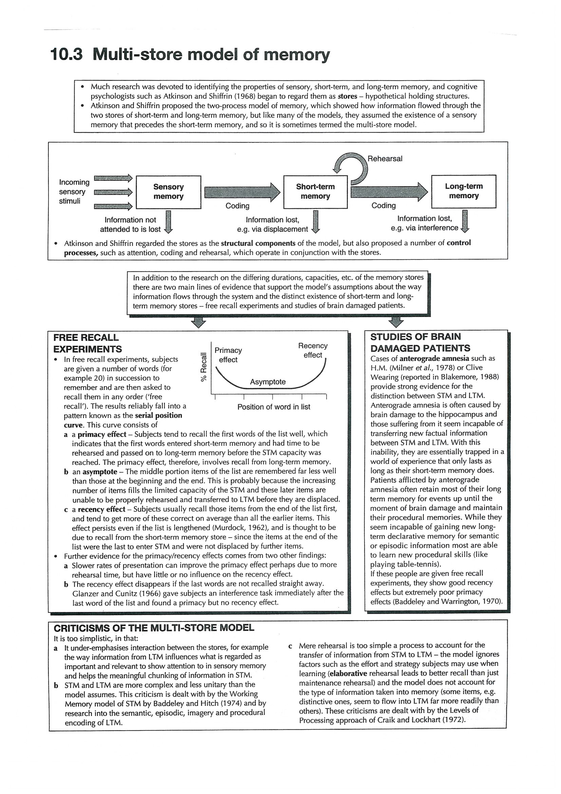
(6) Evaluate two models or theories of one cognitive process (memory) with reference to research studies.

Write up a summary.of the Multistore Model of Memory (Atkinson & Shiffrin, 1968)

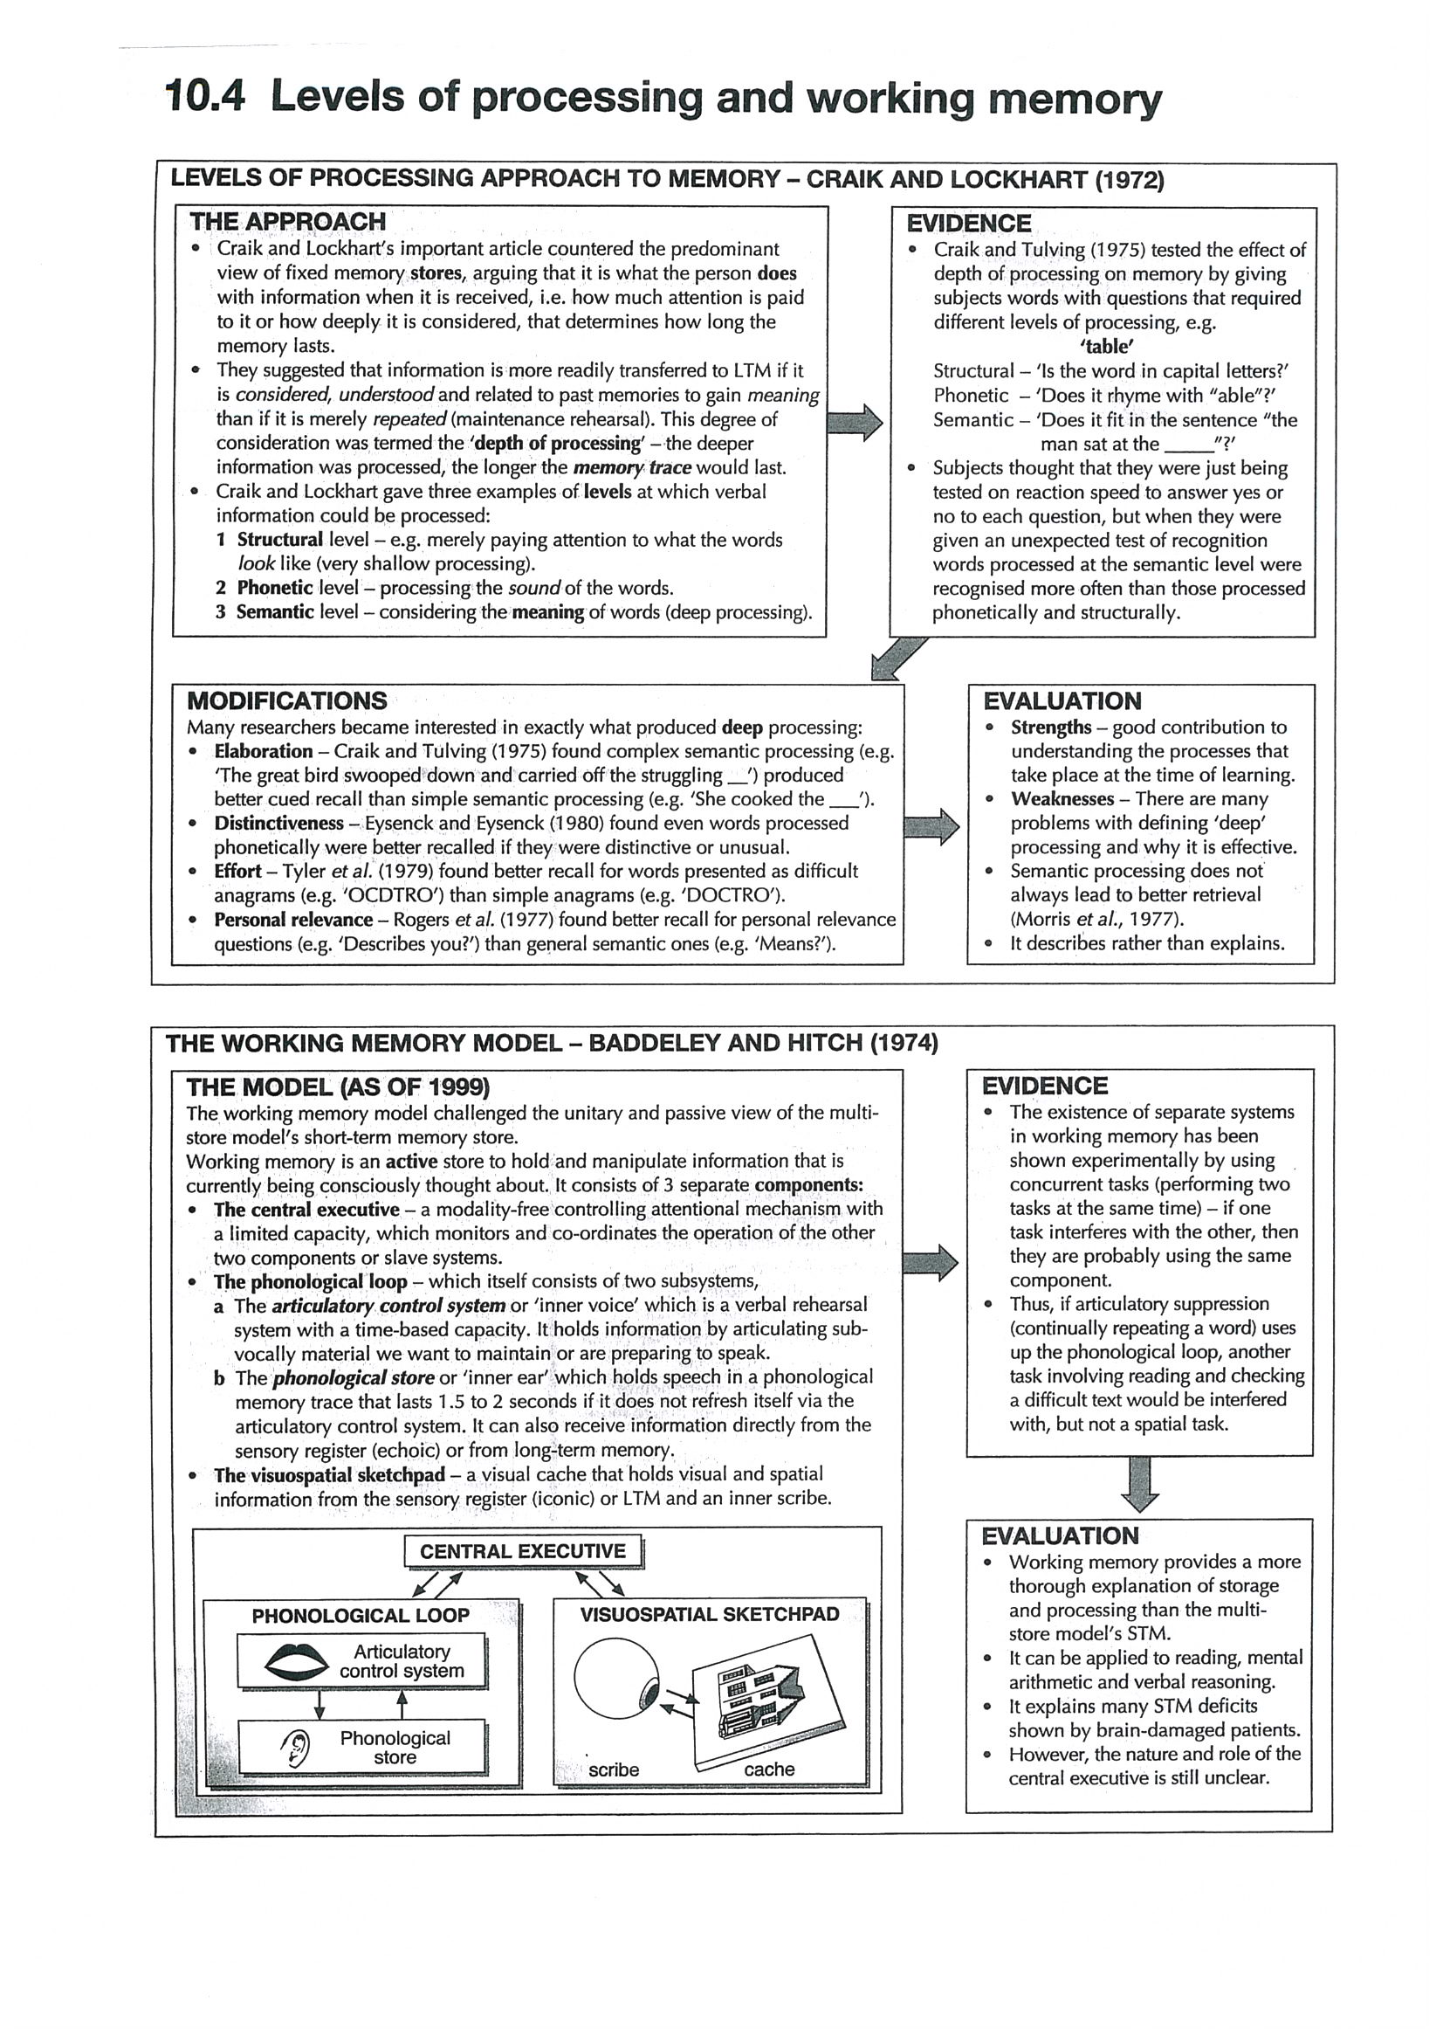

Write up a summary of the Levels of Processing Model (Craik & Lockhart, 1972) or The Working Memory Model Baddely and Hitch (1974)

(7) Explain how biological factors may affect one cognitive process (for example, Alzheimer’s disease, brain damage, sleep deprivation).
The case of Clive Wearing
Clive Wearing is a very talented musician and former master of a major London choir. As a result of an infection with the herpes simplex virus he suffered brain damage that involved the hippocampus. This is very unusual, the herpes simplex virus most commonly causes cold sores. On extremely rare occasions, like Clive’s, it can cause encephalitis which can result in brain damage. Baddeley, one of the psychologists who studied Clive Wearing, describes his memory as follows (Baddeley, 2009).
Clive was densely amnesic and appeared to be unable to store information for periods longer than seconds. His interpretation of his plight was to assume that he had just recovered consciousness, something that he would announce to any visitor, and something that he repeatedly recorded in a notebook, each time crossing out the previous line and writing ‘I just now recovered consciousness’ … an activity that continued for many, many years. Clive knew who he was and could talk about the broad outlines of his early life, although the detail was very sparse … He could not read a book or follow a television program because he immediately forgot what had gone before … He was locked into a permanent present, something he described as ‘hell on earth’ … However, there was one aspect of Clive’s memory that appeared to be unimpaired, that part concerned with music. When his choir visited him, he found he could conduct them just as before. He was able to read the score of a song and accompany himself on the keyboard while singing it … Over 20 years later, Clive is still just as amnesic.
One may add that Clive had retained his linguistic functions and most of the motor and cognitive skills he had before the brain damage. His impairment affected mainly his episodic (including autobiographical) memory. His main problem seems to be his inability to transfer novel information from the STS to the LTS.
Reference
Baddeley A. (2009). What is memory? In: Baddeley A, Eysenck MW, Anderson CA. Memory. Hove and New York: Psychology Press

Write up an evaluation of the following.

H.M The role of damage to the Hippocampus in Memory.
The Case study of Clive Wearing.
Alzheimer’s disease

8. Discuss how social or cultural factors affect one cognitive process

Cross-cultural studies of memory

In developmental psychology, one issue is the development of cognitive abilities such as memory. Most research has been done in the Western world, and an important Swiss psychologist Jean Piaget claimed that cognitive development followed universal laws. It has been assumed that memory tests could therefore be applied all over the world, and it was often found that participants in non- Western countries did poorly on many tests. However, in recent time cross-cultural studies of memories question the results of Western memory tests in non-Western settings. For example, Cole and Scribner (1974) studied the development of memory among tribal people in rural Liberia. To overcome the barriers of language and culture, these researchers observed everyday cognitive activities before conducting their experiments and worked closely with the college-educated local people who acted as experimenters. Even with these precautions, they found striking cultural differences in the way tribal people went about remembering and solving the problems presented by their experimental tasks.
The nature of these cultural differences can be seen in studies of the development of free-recall memory. In a free-recall task people are shown a large number of objects, one at a time, and then asked to remember them. This kind of memory is called “free” recall because people are free to recall the items in any order they wish.
Below is a list of objects used in several of Cole’s studies. The list shows that the objects appear to fall into four distinct categories. To make certain that American categories were not simply being imposed on Liberian reality, the researchers made preliminary investigations to ensure that Liberian participants were familiar with the items used and that they readily separated these items into the four groups indicated in the list.

The word list used in research a number of times by Cole and colleagues

plate cutlass
calabash hoe
pot knife
pan file
cup hammer

potato trousers
onion singlet
banana head tie
orange shirt
coconut hat

The researchers found that unlike children in industrial societies, Liberian children showed no regular increase in memory performance during middle childhood- unless they had attended school for several years. The non-schooled people improved their performance on these tasks very little after the age of 9 or 10. These participants remembered approximatively ten items on the first trial, and managed to recall only two more items after 15 practice trials. The Liberian children who were attending school, by contrast, learned the materials rapidly, much the way schoolchildren of the same age did in the United States.
Important clues to the causes of these differences were revealed by detailed analyses of the order in which the words were recalled. Schoolchildren in Liberia and the United States not only learned the list rapidly but used the categorical similarities of items in the list to aid their recall. After the first trial they clustered their responses, recalling for example items of clothing, then items of food, and so on. The non-schooled Liberian participants did very little such clustering, indicating that they were not using the categorical structure of the list to help them remember.
To track down the source of this difference, the researchers varied aspects of the task. They found that if, instead of a list of objects presented in random order, the same objects were presented in a meaningful way as part of a story, their non-schooled Liberian participants recalled them easily, clustering the objects according to the roles they played in the story.
Similar results have been found on tests of children’s memorisation skills in research among Mayan people of rural Guatemala. When Mayan children were presented with a free-recall task, their performance lagged considerably behind those of age mates in the United States (Kagan et al. 1979). Their performance changed dramatically, however, when Rogoff and Waddel (1982) gave them a memory task that was meaningful in local terms. The researchers constructed a diorama of a Mayan village located near a mountain and a lake, similar to the locale in which the children lived. Each child watched as a local experimenter selected 20 miniature objects from a set of 80 and placed them in the diorama. The objects included cars, animals, people, and furniture- just the kind of things that would be found in a real town. Then the 20 objects were returned to the group of 60 others remaining on the table. After a few minutes, the children were asked to reconstruct the full scene they had been shown. Under these conditions, the memory performance of the Mayan children was slightly superior to that of their United States counterparts.
The implication of these memory studies is that although the ability to remember is a universal intellectual requirement, specific forms of remembering are not universal, and the problem with many memory studies is that they are usually associated with formal schooling.
Schooling presents children with specialised information-processing tasks, such as committing large amounts of information to memory in a short time, learning to manipulate abstract symbols in one’s head and on paper, using logic to conduct experiments, and many more tasks that have few if any analogies in societies without formal schooling. The free-recall task that Cole and his colleagues originally used to assess memory among Liberian tribal people has no precise analogy in traditional Liberian cultures, so it is not surprising that the corresponding way of remembering would not be acquired. The same conclusion applies to a vast majority of tasks psychologists use to investigate various mental processes during childhood and in adulthood, because many of them embody forms of activity that are specific to certain kinds of settings, especially schools and the modern technological workplace-settings that only some cultures provide.

Based on Cole and Cole (1993) The development of Children. 2nd edition. Scientific American Books.

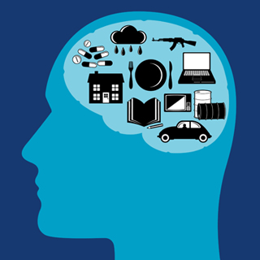
Discuss how social or cultural factors affect one cognitive process – with reference to Cole and Scribner (1974)

(9)) With reference to relevant research studies, to what extent is one cognitive process reliable?

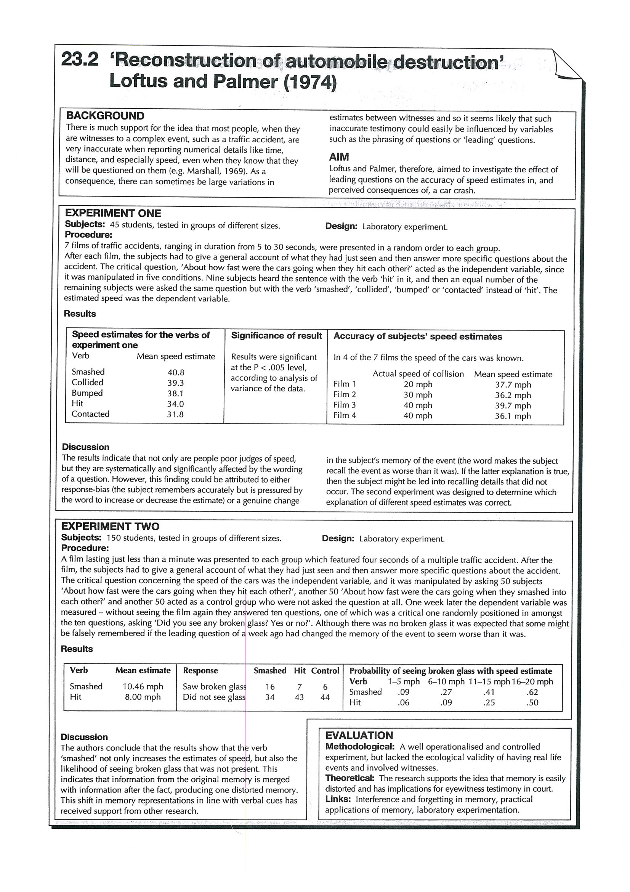
Eyewitness Testimony – Loftus and Palmer (1974)

Aim
Procedure

Findings/Results
Conclusion

Evaluation: Strengths
Evaluation:
Weaknesses

To what extent is one cognitive process reliable?
Write up a summary of the following.
Weapons Focus; Yuille & Cutshall: Yerkes/Dodson Law

10. Discuss the use of technology in investigating cognitive processes

Brain Imaging and Research

Technological advances mean we now have numerous new and exciting ways of obtaining detailed information about the brain's structure and functioning.
In principle, we can now establish where n the brain specific cognitive processes occur, and when these processes occur. Such information can allow us to determine the order in which different parts of the brain become active when someone is performing a task. It also allows us to find out whether two tasks involve the same parts of the brain in the same way, or whether there are important differences. The cerebral cortex is divided into four main divisions or lobes. There are four lobes in each brain hemisphere: frontal, parietal, temporal, and occipital. The frontal lobes are divided from the parietal lobes by the central sulcus (sulcus means furrow or groove), the lateral fissure separates the temporal lobes from the parietal and frontal lobes, and the parieto-occipital sulcus and pre-occipital notch divide the occipital lobes from the parietal and temporal lobes.
Researchers often use various terms to describe more precisely the area of the brain activated during the performance of some task.
Some of the main terns are as follows:

dorsal: superior or on top;
ventral: inferior or at the bottom;
lateral: situated at the side;
medial: situated in the middle.

The electroencephalogram (EEG) is based on recordings of electrical brain activity measured at the surface of the scalp. Very small changes in electrical activity within the brain are picked up by scalp electrodes. These changes can be shown on the screen of a cathode-ray tube by means of an oscilloscope. A key problem with the EEG is that spontaneous or background brain activity sometimes obscures the impact of stimulus processing on the EEG recording.
A solution to the above problem is to present the same stimulus several times. After that, the segment of EEG following each stimulus is extracted and lined up with respect to the time of stimulus onset. These EEG segments are then simply averaged together to produce a single waveform. This method produces event-related potentials (ERPs) from EEG recordings, and allows us to distinguish genuine effects of stimulation from background brain activity.
ERPs are particularly useful for assessing the timing of certain cognitive processes. For example, some attention theorists have argued that attended and unattended stimuli are processed differently at an early stage of processing, whereas others claim they are both analysed fully in a similar way . Studies using ERPs have provided good evidence in favour of the former position. For example, Woldorff et a1. (1993) found ERPs were greater to attended than unattended auditory stimuli about 20-50 milliseconds after stimulus onset.

Evaluation

ERPs provide more detailed information about the time course of brain activity than most other techniques, and have many medical applications (e.g., diagnosis of multiple sclerosis). However, ERPs do not indicate with any precision which regions of the brain are most involved in processing. This is due in part to the fact that the presence of skull and brain tissue distorts the electrical fields emerging from the brain. Furthermore, ERPs are mainly of value when the stimuli are simple and the task involves basic processes (e.g., target detection) occurring at a certain time after stimulus onset. As a result of these constraints (and the necessity of presenting the same stimulus several times) it would not be feasible to study most complex forms of cognition (e.g., problem solving, reasoning) with ERPs.

PET – Positron Emission Tomography

Positron emission tomography or the PET scan is based on the detection of positrons, which are the atomic particles emitted by some radioactive substances. Radioactively labelled water is injected into the body, and rapidly gathers in the brain's blood vessels. When part of the cortex becomes active, the labelled water moves rapidly to that place. A scanning device next measures the positrons emitted from the radioactive water. A computer then translates this information into pictures of the activity levels in different brain areas. It may sound dangerous to inject a radioactive substance into someone, but only tiny amounts of radioactivity are involved.
Raichle (1994b) has described the typical way in which PET has been used by cognitive neuroscientists. It is based on a subtractive logic. Brain activity is assessed during an experimental task) and also during Some control or baseline condition (e.g., before the task is presented). The brain activity during the control condition is then subtracted from that during the experimental task. It is assumed that this allows us to identify those parts of the brain active only during the performance of the task. This technique has been used in several studies designed to locate the parts of the brain most involved in episodic memory, which is longterm memory involving conscious recollection of the past (see Chapter 7). There is more activity in the right prefrontal cortex when participants are trying to retrieve episodic memories than when trying to retrieve other kinds of memories (see Wheeler, Stuss, & Tulving, 1997, for a review).

Evaluation

PET has reasonable spatial resolution, in that any active area within the brain can be located to within about 3 or 4 millimetres. It is also fairly versatile technique, in that it can be used to identify the brain areas involved in a wide range of different cognitive activities.

PET has several limitations. First, the temporal resolution is very poor. PET scans indicate the total amount of activity in each region of the brain over a period of 60 seconds or longer, and so cannot reveal the rapid changes in brain activity accompanying most cognitive processes. Second, PET provides only an indirect measure of neural activity. As Anderson, Holliday, Singh, and Harding (1996) pointed out, "changes in regional cerebral blood flow, reflected by changes in the spatial distribution of intravenously administered positron emitted radioisotopes, are assumed to reflect changes in neural activity." This assumption may be more applicable at early stages of processing. Third, it is an invasive technique, because participants have to be injected with radioactively labelled water. This makes it unacceptable to some potential participants in PET studies. Fourth, it can be hard to interpret the findings from use of the subtraction technique. For example, it may seem plausible to assume that those parts of the brain active during retrieval of episodic memories but not other kinds of memories are directly involved in episodic memory retrieval.
However, the participants may have been more motivated to retrieve such memories than other memories, and so some brain activity may reflect the involvement of motivational rather than memory systems. Fifth, the number of brain areas apparently involved in performance of a task depends very much on the level of statistical significance set by the experimenter. As Savoy (2001) showed, the same PET data may show very few brain areas active during task performance if a very stringent criterion is set, but may show numerous brain areas active if a much more lenient criterion is adopted.

MRI - Magnetic Resonance Imaging

In magnetic resonance imaging (MRI), radio waves are used to excite atoms in the brain. This produces magnetic changes detected by a very large magnet (weighing up to II tons) surrounding the patient. These changes are then interpreted by a computer and turned into a very precise three dimensional picture. MRI scans can be used to detect very small brain tumours. MRI scans can be obtained from numerous different angles. However, they only tell us about the structure of the brain rather than about its functions. The MRI technology has also been applied to the measurement of brain activity to provide functional magnetic resonance imaging (fMRI). Neural activity in the brain produces increased blood flow in the active areas, and there is oxygen and glucose within the blood. According to Raichle (l994), "the amount of oxygen carried by haemoglobin (the molecule that transports oxygen) affects the magnetic properties of the haemoglobin . MRI can detect the functionally induced changes in blood oxygenation in the human brain."

The approach based on fMRI provides three dimensional images of the brain with areas of high activity clearly indicated. It is more useful than PET, because it provides more precise spatial information, and shows changes over shorter periods of time. As a result, fMRI has largely superseded PET. However, it shares with PET a reliance on the subtraction technique in which brain activity during a control task or situation is subtracted from brain activity during the experimental task.

A study showing the usefulness of fMRI was reported by Tootell et al. (l995b). It involved the so-called waterfall illusion, in which lengthy viewing of a stimulus moving in one direction (e.g., a waterfall) is followed by the illusion that stationary objects are moving in the opposite direction. There were two key findings. First, the gradual reduction in the size of the waterfall illusion over the first 60 seconds of observing the stationary stimulus was closely paralleled by the reduction in the area of activation observed in the fMR!. Second, most of the brain activity produced by the waterfall illusion was in V5, an area of the visual cortex much involved in motion perception. Thus, the basic brain processes underlying the waterfall illusion resemble those underlying normal motion perception.

Evaluation

Raichle (1994) argued that fMRI has several advantages over other techniques:
The technique has no known biological risk except for the occasional subject who suffers claustrophobia in the scanner (the entire body must be inserted into a relatively narrow tube). MRI provides both anatomical and functional information, which permits an accurate anatomical identification of the regions of activation in each subject. The spatial resolution is quite good, approaching the 1-2 millimetre range.

However, fMRI provides only an indirect measure of neural activity. As Anderson et al. (1996) pointed out, "With fMRI, neural activity is reflected by changes in the relative concentrations of oxygenated and deoxygenated haemoglobin in the vicinity of the activity." Another limitation is that it has poor temporal resolution of the order of a few seconds, so we cannot track the detailed time course of cognitive processes. A further limitation is that it relies on the subtraction technique, and this may not accurately assess brain activity directly involved in the experimental task.
Finally, as with PET, the number of brain areas apparently involved in performing any given task depends very much on the stringency or leniency of the criteria used to evaluate the data. As Savoy (2001) argued, "Will area A in the cortex show a change in activity (an increase or decrease) in response to task X, compared to its response to task Y? If our imaging system is powerful enough ... then the answer will almost always be Yes, for any A, X, and Y."

Magneto-encephalography – MEG

Magneto-encephalography or MEG was developed during the 1990s. It involves using a superconducting quantum interference device (SQUID) to measure the magnetic fields produced by electrical brain activity. It can be regarded as "a direct measure of cortical neural activity" (Anderson et aI., 1996). MEG provides very accurate measurement of brain activity, in part because the skull is virtually transparent to magnetic fields. Thus, magnetic fields are little distorted by intervening tissue, which is an advantage over the electrical activity assessed by the EEG. Anderson et al. (1996) used MEG in combination with MRI to study the properties of an area of the visual cortex known as V5.
MEG revealed that motion-contrast patterns produced large responses from V 5, but that V 5 was unresponsive to colour. These data, in conjunction with previous findings from PET and fMRI studies, led Anderson et al. (1996) to conclude that "these findings provide strong support for the hypothesis that a major function of human V5 is the rapid detection of objects moving relative to their background." In addition, Anderson et al. (1996) obtained evidence that V5 was active approximately 20 milliseconds after VI (the primary visual cortex) in response to motioncontrast patterns. This is more valuable information than simply establishing that VI and V5 are both active during this task, because it suggests that activity in V 1 preceded that in V 5.

MEG possesses several valuable features. First, the magnetic signals reflect neural activity reasonably directly. In contrast, PET and fMRI signals reflect blood flow, which is assumed in turn to reflect neural activity. Second, MEG supplies detailed information at the millisecond level about the time course of cognitive processes. This matters because it makes it possible to work out the sequence of activation in different areas of the cortex. There have been developments in MEG technology in recent years, with the result that the spatial resolution of MEG now resembles that of MRI.
Initially, there were some technical problems associated with the use of MEG, but these problems have been largely (or entirely) resolved. Accordingly, MEG is a valuable tool for assessing brain activation during performance of cognitive tasks.

Transcranial Magnetic Stimulation - TMS

Transcranial magnetic stimulation (TMS) is a technique in which a coil (or pair of coils) is placed close to the participant's head, and a very brief but large magnetic pulse of current is run through it. As a result, there is a short-lived magnetic field, which inhibits processing activity in the area affected. In practice, several magnetic pulses are usually administered in a fairly short period of time; this is known as repetitive transcranial magnetic stimulation (rTMS).
Why are TMS and rTMS useful? In essence, TMS or rTMS creates a "temporary lesion", so that the role of some brain area in performing a given task can be assessed. If TMS applied to a particular brain area leads to impairment of performance on a task, it is reasonable to conclude that that brain area is necessary for normal task performance. Conversely, if TMS has no effects on task performance, then the brain area affected by it is not needed to perform the task effectively.
We will briefly consider one study to show how useful rTMS can be. There has been much controversy concerning the degree of similarity between visual perception and visual imagery. Everyone agrees that primary visual cortex (also known as Area 17) plays a crucial role in visual perception, and so it is of interest to find out whether it is also involved in visual imagery. Kosslyn et al. (1999), using PET, found that Area 17 was activated during a visual imagery task. This makes it likely that Area 17 is necessary for visual imagery, but does not definitely establish the point. However, Kosslyn et al. also found when applying rTMS to Area 17 that performance on the imagery task was impaired, which is strong evidence that that area is necessary for good performance on the task.
TMS is a technique with exciting potential. Of special importance, it can be used to show that activity in a particular area of the brain is necessary for normal levels of performance on some task. Thus, we are often in a stronger position to make causal statements about the brain areas underlying performance when we use TMS than when we use most other techniques. TMS is perhaps of particular importance when used in conjunction with other techniques. For example, fMRI or PET can be used to identity the brain areas that are active when a given task is performed. TMS can then be used to decide which of these brain areas is essential for task performance (as in Kosslyn et aI., 1999). Savoy (2001) identified three major limitations with TMS. First, there are some concerns about safety, especially when magnetic pulses are presented repeatedly in rapid succession. For example, seizures have been induced in normal individuals when a presentation rate of5-IO pulses per second has been used (Savoy, 2001). In practice, however, magnetic pulses are typically spaced sufficiently in time to ensure that participants will not suffer from seizures. Even when this is done, there can nevertheless be minor physical discomfort if TMS activates muscles in the head or face.
Second, TMS has limited spatial resolution. It is hard to ascertain the precise spatial resolution, but it is clear that the area affected by TMS is fairly large (Pascual-Leone, Bartres-Faz, & Keenan, 1999). The peak brain activity triggered by TMS may cover about 0.5-1.0 cm, but activation may extend well beyond this area (Savoy, 2001). Third, the length of time for which TMS affects brain activity is not known with any precision. There is an additional limitation that should be mentioned. TMS is much more effective when applied to some brain areas than to others. More specifically, it does not work well in areas where there is overlying muscle.

PET

Definition:

Studies:

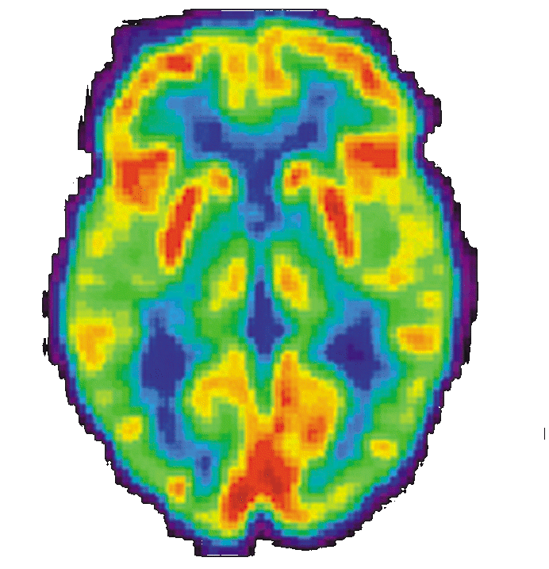

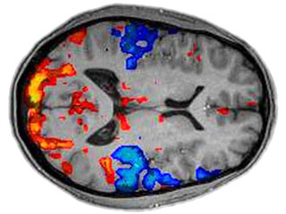
MRI & fMRI

Definition:

Studies:

MEG

Definition:

Studies:

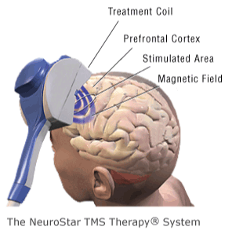
TMS

Definition:

Studies:

Cognition and Emotion.

11. To what extent do cognitive and biological factors interact in emotion (for example, two factor theory, arousal theory, Lazarus’ theory of appraisal

Discuss the two Factor Theory of Emotion (Schachter & Singer, 1962)

Appraisal Theory (Lazarus)

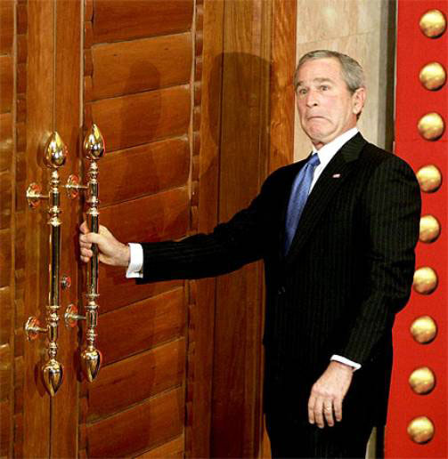

12. Evaluate one theory of how emotion may affect one cognitive process (for example, state-dependent memory, flashbulb memory, affective filters).

Flashbulb Memory

