Attribution Theory.
Heider (1958) The Layperson as a Naive Psychologist
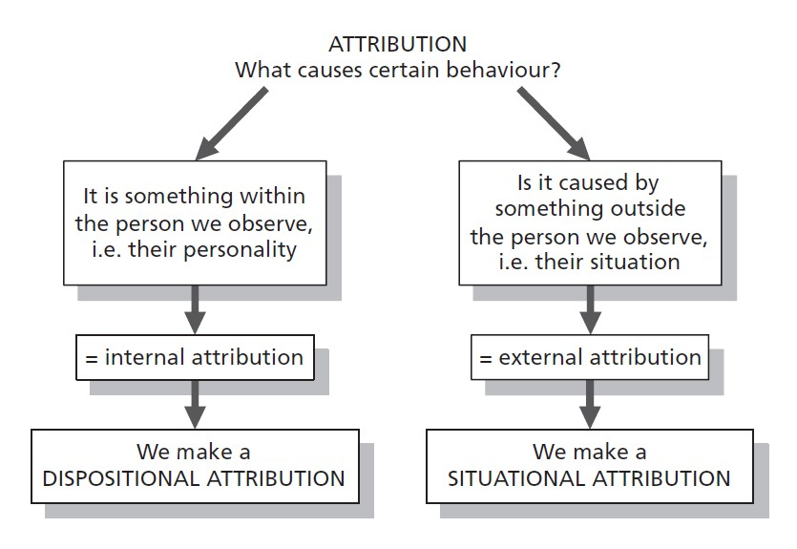
How do we attach meaning to other's behaviour, or our own? This is called attribution theory. For example, is someone angry because they are bad-tempered or because something bad happened?

“Attribution theory deals with how the social perceiver uses information to arrive at causal explanations for events. It examines what information is gathered and how it is combined to form a causal judgment” (Fiske & Taylor, 1991)
Attribution theory is concerned with how and why ordinary people explain events as they do.
Heider (1958) believed that people are naive psychologists trying to make sense of the social world. People tend to see cause and effect relationships even where there is none!
Heider didn’t so much develop a theory himself as he emphasised certain themes that others took up. There were two main ideas that he put forward that became influential.
1. When we explain the behaviour of others we look for enduring internal attributions, such as personality traits. For example we attribute the behaviour of a person to their naivety or reliability or jealousy.
2. When we try to explain our own behaviour we tend to make external attributions, such as situational or environment.

